**Final Project**

Group 5

Sim Arora

Phuong Nam Pham

**1 User Story (5 points)**

1. **As a user**, I want to login to access the full functionality of the app.
2. **As a user,** I want all the app functionality to be displayed and easily accessible.
3. **As a student**, I want to list course information so that I can check course names, descriptions, and timings.
4. **As a student**, I want to enrol in courses online so that I can easily register without needing to visit administrative offices.
5. **As a student**, I want to create a personalized timetable so that I can visualize my weekly schedule and manage my time effectively.
6. **As a student**, I want to receive notifications for upcoming assignments and exams so that I can prepare in advance and stay organized.
7. **As a student**, I want to communicate with my peers through a messaging feature so that we can collaborate on projects and share ideas.
8. **As an educator**, I want to upload and update lecture notes and assignments so that students have access to the most current information.
9. **As an educator**, I want to track student attendance so that I can monitor engagement and participation in class.
10. **As a student**, I want to submit assignments through the app so that I can easily manage my submissions and receive feedback electronically.

**2 Design (5 points)**

**3 Technology (10 points)**

1. Which control did you use in your app? Did you create custom control?

We use WinForms app to create the project

1. Did you save data into the database? Which method did you connect database, ADO.NET or Entity Framework?

Data is currently stored and extracted in csv format

**4 Functionalities (70 points)**

1. User Story 1 Login credentials

There’s no database implementation so currently all the login credentials are hard-coded into the form itself.

Accepted username: user, admin, student, teacher, p.pham746  
Accepted password: password, 0000, 453746

2. User Story 2 Accessible menu

5 more forms were made according to user stories. All are accessed by clicking the corresponding button.

3. User Story 3 Display all courses

Courses information was stored in a csv file. Then was extracted during loading of the Login screen and stored in in a static class. This page take those information and display as a table

4. User Story 4 Enrollment

Username (from login screen) is stored in a static class. Here it’ll be used to check if user is already enrolled or not. If not, then add user to the student list of that course

5. User Story 5 Personal timetable

Using updated information after enrollment, Timetable only displays the course that user had enrolled in (by checking if student list contains their name or not).

6. User Story 6

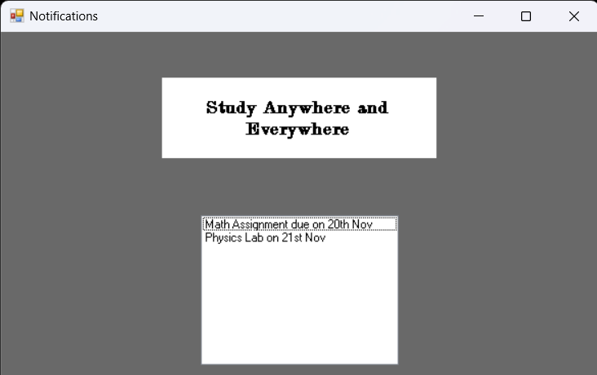

Display notifications. Currently the notifications are hard-coded with the code and not from external source

7. User Story 7 Messaging

Store conversations and allow user to choose who they send messages to by clicking on the name on the list next to display or enter manually in the left text box. If user sent message to receiver not on the list, create new conversation

8. User Story 8

9. User Story 9

10. User Story 10

**5 Submission (10 points)**

Push your code on GitHub and paste the GitHub repository like here

https://github.com/pnam0204/SODV2101-Group5Project.git